Name:_________________

**Pythagorean Theorem Practice #1**

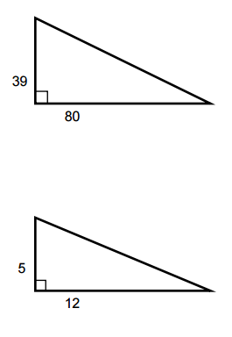Find the missing hypotenuse for each of these right triangles. Please show all work. 